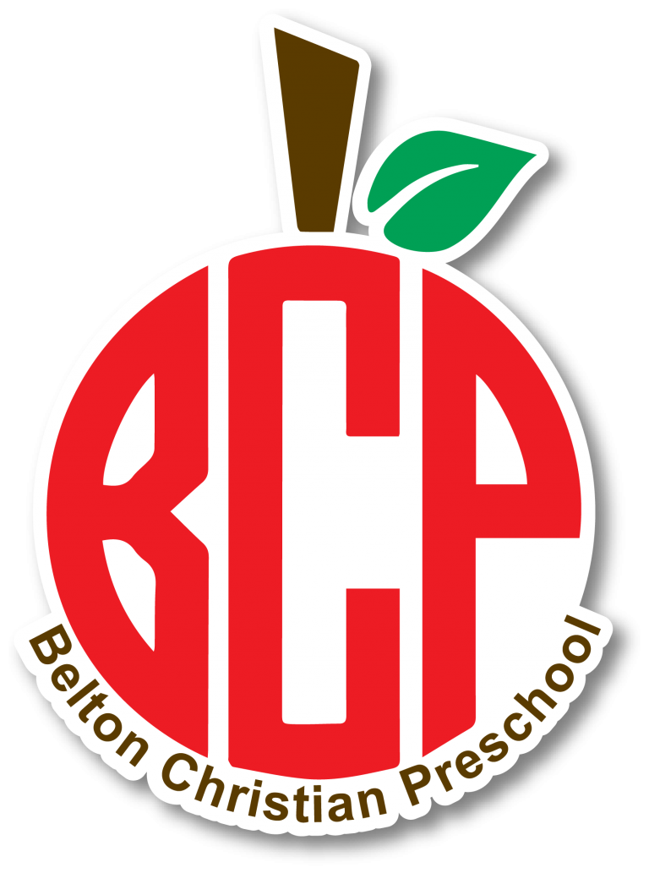

2024-2025
Parent Handbook

Belton Christian Preschool
Mission Statement and Philosophy

Belton Christian Preschool is an extension of the total ministry of the Church, and is an outreach and service not only to our members, but also to our community. We believe that every child is a blessing from God. Our desire is to provide a safe and nurturing environment where children can grow both spiritually and socially. Our preschool strives to develop a partnership with families that will enhance each child’s learning experience.

Curriculum:
In our 12-24 month classes, young learners are encouraged to experience their environment through sensory play and hands-on activities. At this age, teachers operate on the child’s schedule!
We employ a center-based approach in our 2 yr. old through Pre-K programs. Children are encouraged to explore activities in these centers that are designed to emphasize readiness skills such as recognizing letters, shapes, colors, and numbers, as well as other developmental skills.
Thematic units are implemented in classrooms. Teachers post monthly calendars indicating weekly themes and Bible lessons. The weekly themes are integrated into circle times, learning centers, and other educational activities. Examples of the types of centers used in the classroom are arts and crafts, dramatic play, library, and sensory play.
During circle time, children will participate in story time, Bible stories, finger plays, calendar time, and singing. Our 3’s and Pre-K classes attend chapel once a week starting in September, and our 2s classes join them in January. Children will hear Bible stories and sing songs using the Grow curriculum.
In addition to the theme for the week, our Pre-K classes also use a printed curriculum, The Good and The Beautiful.

Music Curriculum:
Children will attend music each day and receive instruction in music and movement. In addition to the exciting things they will be experiencing during class, they will perform for parents at two programs during the year.
Fieldtrips/Special Events:
Our Pre-K classes will go on one field trip during the year. Each child must have a signed parent permission form in order to participate in the trip. If your child rides in the church van, we ask that you leave a car seat, labeled with your child’s name, on the day of the trip. However, we love to have parents come along, and you are more than welcome to transport your own child.

Registration and Fees:
Registration Fee: When registering your child, you will need to fill out a registration form and pay a $125 registration fee to hold your child’s spot. This fee is non-refundable.
Supply Fee: A supply fee of $35 is due at the beginning of the school year to cover the cost of all of the different materials your child will use. The Pre-K and Kinder Prep supply fee is $50 to supplement the additional cost of the printed curriculum.
Snack Fee: A $40 snack fee is required at the beginning of the school year to cover the snacks that each child will receive every day. Every snack will be peanut, dairy, and egg free. If your child has any other allergies that need to be considered when we serve snacks, please let us know. You may opt out of the snack fee and provide your child with his or her own snack.

Optional and Occasional Fees:
Occasionally, a small fee may be required for a special fieldtrip or event. In this case, parents will be notified through the Brightwheel app.

Tuition:
Beginning in September, and continuing through May, tuition is due on the 1st of every month. You may pay tuition through Brightwheel, check or cash. Tuition is considered late after the 15th of the month, and a $10.00 late fee will be added to your balance. When tuition has become two weeks past due, and no payment arrangements have been made, your child will be dropped from the preschool to allow someone on the waiting list to fill the spot.
There will be a $15.00 charge for all returned checks. If a check is returned more than one time, only cash will be accepted for tuition.
A written notice is required two weeks prior to withdrawing a child from the preschool. Tuition that has been paid for the current month will only be refunded on a prorated schedule if the 2 week notice has been given.
Tuition amounts will remain the same each month September through May regardless of the number of days children attend. There will be no reduction in tuition when there are scheduled breaks such as Christmas and Spring Break.

Arrival and Departure Procedures:
A parent or adult must accompany your child before, and after, school. Your child should never enter or leave the preschool alone. You will check in and check out your child through the Brightwheel App. If there is a new adult picking up your child, please let the teacher know. If the teacher is not familiar with the person picking up your child, they will be asked to present an ID. Approved pickups may be added to the Brightwheel app.
The doors will be unlocked at 8:50 each morning. Please do not bring your child before this time. Teachers are preparing for their classes and will not be available to receive your child. Children attending Early Bird should not arrive earlier than 8:00.
We also appreciate your promptness in picking up your child. If you know you will be late, a phone call is appreciated. After 2:35, children who have not yet been picked up will be taken to Late Day, and parents will be charged a $10.00 fee for that hour. Late day ends at 3:30, and the doors will lock. Any parents that pick up after the doors locked will have a $5 base late charge plus $1 for every additional minute the child remains in the building, regardless of whether the parent is also in the building.
Please be respectful of your teacher’s time. They have other responsibilities before the end of their work day. Any concerns or conversations with the teacher should occur prior to 3:30 or over Brightwheel.

Entrance Doors:
We ask that you and your child enter through the double doors on the right side of the building. For safety reasons, these doors will be locked around 9:30 each morning and unlocked each afternoon at 2:15. If you need to come into the preschool in between these times, please ring the doorbell that is located by the handles on these doors. We will open the door for you.

Open Door Policy:
Parents are welcome to visit our preschool at any time to observe or to visit with your child. If you plan on staying for an extended amount of time, please schedule your visit in advance with your child’s teacher. This rule does not apply to special events and classroom parties.
Conferences with the teacher may be arranged before or after school. We encourage you to communicate any and all concerns to the director. We are here to serve you and we take your concerns and suggestions very seriously. If we are unable to resolve your concerns, we may contact the Belton Church of Christ elders to bring about a resolution to the issue.

Background Checks:
BCP runs a background check (including criminal history check and sexual offender registry check) on every member of our staff. We also run checks on our substitutes and anyone else who might be supervising the children. While we do not require a check for every parent who visits for parties or special events, we reserve the right to ask permission to run a background check if we feel that it is necessary to ensure our children’s safety.

Children with Special Needs:
Children with special needs are evaluated on an individual basis in order to determine if their needs can be met. Acceptance will be at the discretion of the director.

Injuries:
Small injuries (skinned knees, bumps, etc.) will be treated by the teacher or director. Parents will receive an accident report on any injury occurring while at the preschool through the Brightwheel app.
In case of a major accident, a parent or the person listed as the emergency contact will be notified. If we are unable to reach the parent and the emergency contact person, the director will contact the child’s physician. If the physician or an ambulance must be used, the parent will be responsible for any resultant expenses.

Illness:
You will be notified to pick up your child if he/she becomes ill while at preschool. Parents will be called if a child has a temperature of 100.4 degrees or higher. Children may not return to school until they have been free of fever for 24 hours (without the aid of fever reducing medication). If a teacher suspects your child is still sick upon returning to school, the director will be notified and will determine whether or not the child is well enough to remain at school.
You will also be contacted if your child shows any symptoms of severe illness such as lethargy, uncontrolled breathing, uncontrolled diarrhea, vomiting, rash with fever, mouth sores, or wheezing.
Please do not bring your child to school with any of the above symptoms. Notify the director if your child has contracted a communicable disease. A notice must be sent home to alert parents to their child’s exposure to the communicable disease.

Medications:
Medications should be given at home before arriving at school. In the event your child needs to have medication administered at school, the medication must be accompanied by a doctor’s note, or parent note, and must be in the original container labeled with your child’s name. Only the director will be allowed to dispense medication at school. Please do not send your child to school with fever rec

Discipline and Guidance:
At BCP, we strive to be consistent and developmentally appropriate when administering discipline. Corporal punishment is never used. Teachers are trained to redirect inappropriate behavior by showing the child a more appropriate way to handle a particular situation. Praise is frequently used to reinforce acceptable behavior. We also use time-out as a way to separate the child from the situation and give them time to think about their actions. If these forms of discipline are ineffective in deterring the unwanted behavior, the teacher and/or director will work with the parents to decide on a strategy that will help the child make an appropriate choice when a particular situation occurs. Examples of appropriate consequences include:
Action | Consequence
Big Messes | They are in charge of picking up.
Not listening/obeying | Redirect, Model expectation, Time out
Hitting/kicking/biting | Time out

Dismissal from the program will occur when:
- The child has been sent home from preschool for hitting and/or biting 3 separate times.
- The school has exhausted all other forms of behavior management strategies created by the director, teacher and parents.

Potty Training:
We understand that children all develop at different rates and therefore potty train at different ages. However, due to the higher demands of the curriculum in pre-k, and the lack of an appropriate place to change diapers, we require all children to be potty trained before entering the pre-k class.
Since our students are only here two days a week, we are unable to provide the consistency to potty-train your child. However, we will attempt to assist you as your child begins the process. We ask that you send a Pull-up in your child’s bag until they are able to consistently make it through the school day without having an accident.

Napping:
There will be a naptime in every class except for Pre-K. If your child is unable to nap, they may be offered books or quiet activities during this time. However, your child is expected to stay quietly on the nap mat during naptime so that the other children have the opportunity to sleep. If your child is not able to sit quietly on their nap mat, a meeting with the director may be set up to discuss the situation.

Snacks:
One snack will be provided each day to every child. This snack will be peanut, dairy, and egg free. If you would like to see a list of the approved snacks that could be served, please let us know. Also, if your child has any other allergies, please let us know so that we can adjust the snack list to accommodate their needs.

Lunch:
Children should bring their lunch each day in a labeled container or lunchbox. Food should not require preparation or heating. BCP is a peanut-free environment, so there is no peanut butter or other peanut products allowed in our building. If you choose to pack your child a “peanut butter alternative” such as sun butter or almond butter, please label the item. Otherwise, it might be mistaken for peanut butter and your child would not be able to have it.

Clothing:
Parents are encouraged to dress their children in comfortable, casual clothes. Your child will participate in many activities that could cause them to become messy. We do use washable paint to try and keep stains to a minimum, but please refrain from sending them in their “Sunday best.” Please have your child wear shoes that are safe to play in the gym and outside. We also ask that you keep an extra pair of weather-appropriate clothing in your child’s bag. Please label these clothes, and any other items sent from home, with your child’s first and last name.

Items from Home:
The preschool provides safe, adequate, and educational toys. We prefer that toys and unnecessary items be left at home. If your child has an item or book that goes along with the weekly theme, please ask the teacher before bringing it to share with the class. We are not responsible for lost items.

Birthday Parties:
We love to celebrate birthdays! If you would like to bring a special snack on your child’s birthday, please make arrangements with your child’s teacher. Any snacks brought for birthday celebrations must either be on the approved snack list or approved by the director. Your child’s teacher and/or the director would be glad to discuss ideas with you if you have any questions. Gifts should not be given at school. Invitations to birthday parties may only be distributed if every child in the class receives one.

Bad Weather Closings:
Belton Christian Preschool will be closed for bad weather if Belton Independent School District is closed. If BISD is delayed (ex 10 AM), BCP will open 30 minutes after BISD (ex. 10:30). Listen for these announcements on the local TV stations, and watch for alerts through the Brightwheel app.

Holidays:
Belton Christian Preschool follows the same calendar as Belton Independent School District. We will be closed on any and all holidays that they observe. We may have additional holidays or other school closings as we see fit.

Newsletters:
The director will send home a monthly newsletter through Brightwheel on or before the first school day of every month. This letter will include reminders and information on upcoming events.

Belton Christian Preschool
Parent Handbook

This handbook has been prepared for you to acquaint you with the school’s policies and procedures. Please keep a copy of the handbook in your records to reference. Any changes made to the handbook throughout the school year will be sent home as an amendment to be signed by a parent. If you have any questions, please contact the director by emailing Katee@beltonchurch.com.

Katee Cormier
Preschool Director

I have read and understand the policies and procedures outlined in the Belton Christian Preschool Parent Handbook. I understand that failure to abide with these guidelines may result in suspension or expulsion from the program.

_______________________________ ____________________________
Student Teacher

_______________________________ ____________________________
Signature Date

